Matplotlib Challenge Write Up

In this project, I received a dataset of 10 different drug regimen. The drugs were tested on 249 mice, however one mouse had to be erased from the study due to faulty, duplicate data, resulting in only 248 mice. Data recorded were Mouse ID, Drug Regimen taken, Sex of Mouse, Age(months), Weight(g), Timepoint, Tumor Volume (mm3), and Metastatic Sites. The timepoint column was different points in the study where tumor volume was recorded. As shown below, there are multiple timepoints with an observed tumor volume.

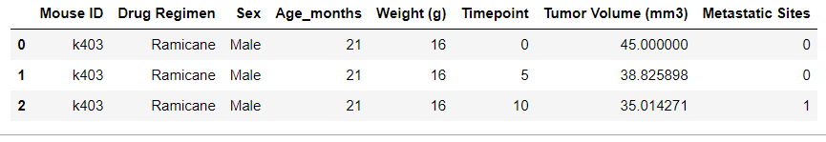

First observation: the best drug regimen in the study were Capomulin and Ramicane. They had the lowest average tumor size. And they were keeping the mice alive longer which enabled them to conduct more timepoints which is displayed in second figure below. Another startling finding was the drug Propriva which couldn’t keep the mice alive longer than the placebo. So, in fact, the drug Propriva was killing the mice. So, the mice were better off with the placebo than Propriva.

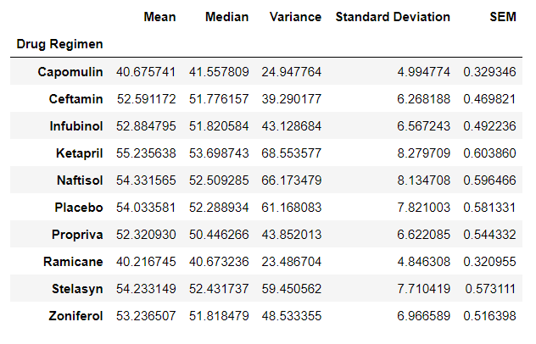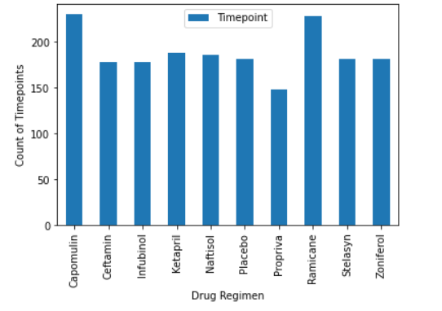

Second Observation: And out of Capomulin, Ramicane, Infubinol, Ceftamin drug regimens, we only encountered one outlier. Infubinol data had the outlier and may have skewed the data. Additionally, sex of the mice were nearly equal with 50.4% male and 49.6% female.

Third observation: Capomulin treatment was tracked on mouse ID, s185. Line graph showed effective results in reducing the size of the tumor. Nearly, 50% reduction in tumor volume in the 45 timepoint units. This drug regimen needs to be analyzed further to expand on these great results.

Fourth observations: we discovered a positive correlation between the weight of the mouse and the size of the tumor. The idea is the more weight the mouse has the more probability the tumor volume will be larger, being positively correlated to weight.

